P.O. Box 1026

Texas Superior Animal Waterer, LLC
“DESIGNED FOR THE HORSE”
Fulshear, Texas 77441
tsaw@global-us.net 281-346-8337 Fred Bray (cell) 281-658-3828 www.texassuperioranimalwaterer.com

Installation # 17500
This installation is for overhead water supply utilizing
½” PEX. The PEX can be substituted with ½” PVC (if needed)

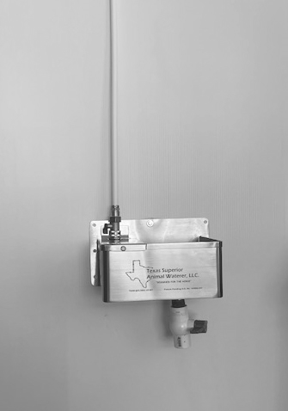
# 19105-1” FPT x 1” FPT PVC Ball
Valve with # 19146 – 1” Sch. 80 MPT PVC Close Nipple
The recommended height of installation of the waterer is 36” to 40” above the stall floor.
# 17276 – ¼” x 1” Long Lag Bolt with flat washers (7 required)
Do not over tighten garden hose threaded fittings; get them snug and go ¼ turn more.
# 17101 – ¾” MHT x ¾” MHT
Brass Fitting
# 17115 – ¾” MHT x ¾” FHT
Brass Shut-Off Valve
# 17105 – ¾” FHT x ½” MPT
Brass Fitting
For Installation Protection Covers complete with Insulation and mounting screws refer to Installation Kits # 17725 PVC (3” flanged PVC Cover) &
# 17725 SS (Stainless Steel)
# 18102 – ½” PEX x ½” MPT
Fitting with PEX clamps # 18109

This installation kit includes all items reflected on this page except for the inlet water supply. Waterer is not included.

# 17276 – ¼” x 1” long lag bolts (7 req’d)
Do not over- tighten garden hose threaded fittings; get them snug and go ¼ turn more.
# 17115 – ¾” FGH x ¾”
MGH Brass Shut-Off Ball Valve
P.O. Box 1026

Texas Superior Animal Waterer, LLC
“DESIGNED FOR THE HORSE”
Fulshear, Texas 77441
tsaw@global-us.net 281-346-8337 Fred Bray (cell) 281-658-3828 www.texassuperioranimalwaterer.com

Installation # 17520
This installation is for underground water supply utilizing ½” PEX. The PEX can be substituted with ½” PVC (if needed)

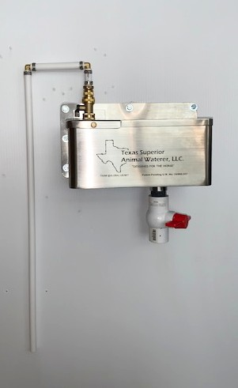# 18101 – ½” PEX x ½”
# 18110 – ½” PEX
Tubing x 4 ¾” long
# 18102 – ½” PEX x ½”
MPT Brass Fitting
PEX Brass 90 degree Ell with # 18109 – ½” PEX
# 17113 – ¾” FGH x ½”
FPT Swivel Brass Fitting

# 18110 – ½” PEX
Tubing x 1 ½” long
# 17101 – ¾”MGH x ¾”
MGH Brass Fitting. Screws into float.

For Installation PVC
Protection Cover Refer to Installation # 17530
# 19105 – 1” FPT x 1” FPT
PVC Ball Valve with
# 19146 – 1” Sch. 80 MPT
PVC Close Nipple

This installation kit includes all items reflected on this page except for the inlet water supply from the customer, Waterer is not included.
The recommended height of installation of the waterer is 36” to 40” above the stall floor
½” PEX tubing (customer inlet water supply). Not included in this kit.

Installation # 17530
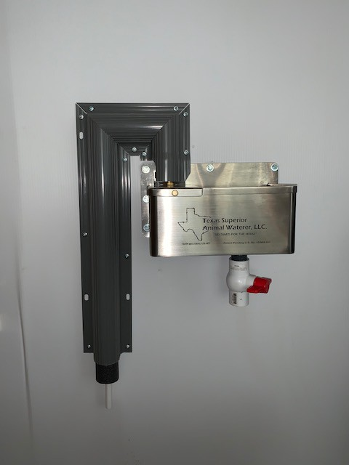This installation / Protection Cover is for underground water supply utilizing ½” PEX. The PEX can be substituted with ½” PVC (if needed)
Also Offered Is a Polished Stainless Steel Cover in place of the PVC if you so choose.
Both are equally functional but the stainless steel is more attractive in appearance.
Allow ¼” space between the top of the float cover to the bottom of the protection cover
When purchasing this cover a detail of the access cut-out is provided to operate the shut-off valve. This is very easy to do. An insulation detail of how to insulate around the shut-off valve is also provided. Refer to Installation # 17900 for details. The valve handle goes on this side.
# 17275 - #8 x 1” long lath
screws (2 pkgs. of 5)
# 16109 BLG 3” PVC Protection Cover. This comes mitered as shown in illustration. This makes for quick and easy installation. The bottom of the cover goes a couple inches below grade.

This installation kit includes the 3” PVC Protection Cover, foam self-sealing adhesive insulation behind the cover & 7 mounting screws. The PVC cover
The inlet line is from the customers water supply source and is not included with this kit.
# 17277 mitered
self-sealing adhesive foam insulation. The insulation is pre-cut to accommodate the installation as illustrated.
To see fittings under this protection cover refer to Installation # 17520
comes cut and mitered as shown in the illustration as does the insulation.

Installation Kit # 17725
This installation / Protection Cover is a flanged PVC Protection Cover with foam insulation behind the cover. This cover works well with installation # 17500. A polished stainless steel cover is also available.

# 17275 - #8 x 1” long lath screws (pkg. of 10)

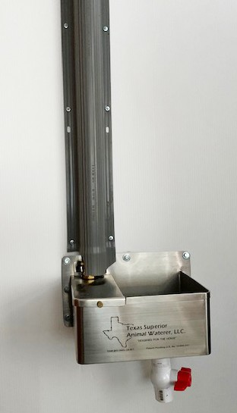When purchasing this cover a detail of the access cut-out is provided to operate the shut-off valve, which is very easy to do. An insulation detail of how to insulate around the shut-off valve is also provided. Refer to Installation # 17900 for details.
Allow ¼” space between the top of the float cover to the bottom of the protection cover.
#16109 PVC STR – 3” Gray PVC cover
comes in 2 pieces that are each approx. 36” long. The #17277 foam insulation comes with 1 piece 36” long and 1 piece 24” long. It also comes with 2 zip ties for insulation around the shut-off ball valve.
The valve handle goes on this side.

This installation kit includes the 3” PVC Flanged Protection Cover, foam self-adhesive insulation behind the cover & mounting screws.

Installation Kit # 17725
This installation / Protection Cover is a flanged PVC Protection Cover with foam insulation behind the cover. This cover works well with installation # 17500. A polished stainless steel cover is also available.

# 17275 - #8 x 1” long lath screws (pkg. of 10)

When purchasing this cover a detail of the access cut-out is provided to operate the shut-off valve, which is very easy to do. An insulation detail of how to insulate around the shut-off valve is also provided. Refer to Installation # 17900 for details.
Allow ¼” space between the top of the float cover to the bottom of the protection cover.
#16109 PVC STR – 3” Gray PVC cover
comes in 2 pieces that are each approx. 36” long. The #17277 foam insulation comes with 1 piece 36” long and 1 piece 24” long. It also comes with 2 zip ties for insulation around the shut-off ball valve.
The valve handle goes on this side.

This installation kit includes the 3” PVC Flanged Protection Cover, foam self-adhesive insulation behind the cover & mounting screws.

Texas Superior Animal Waterer, LLC
tsaw@global-us.net 281-346-8337

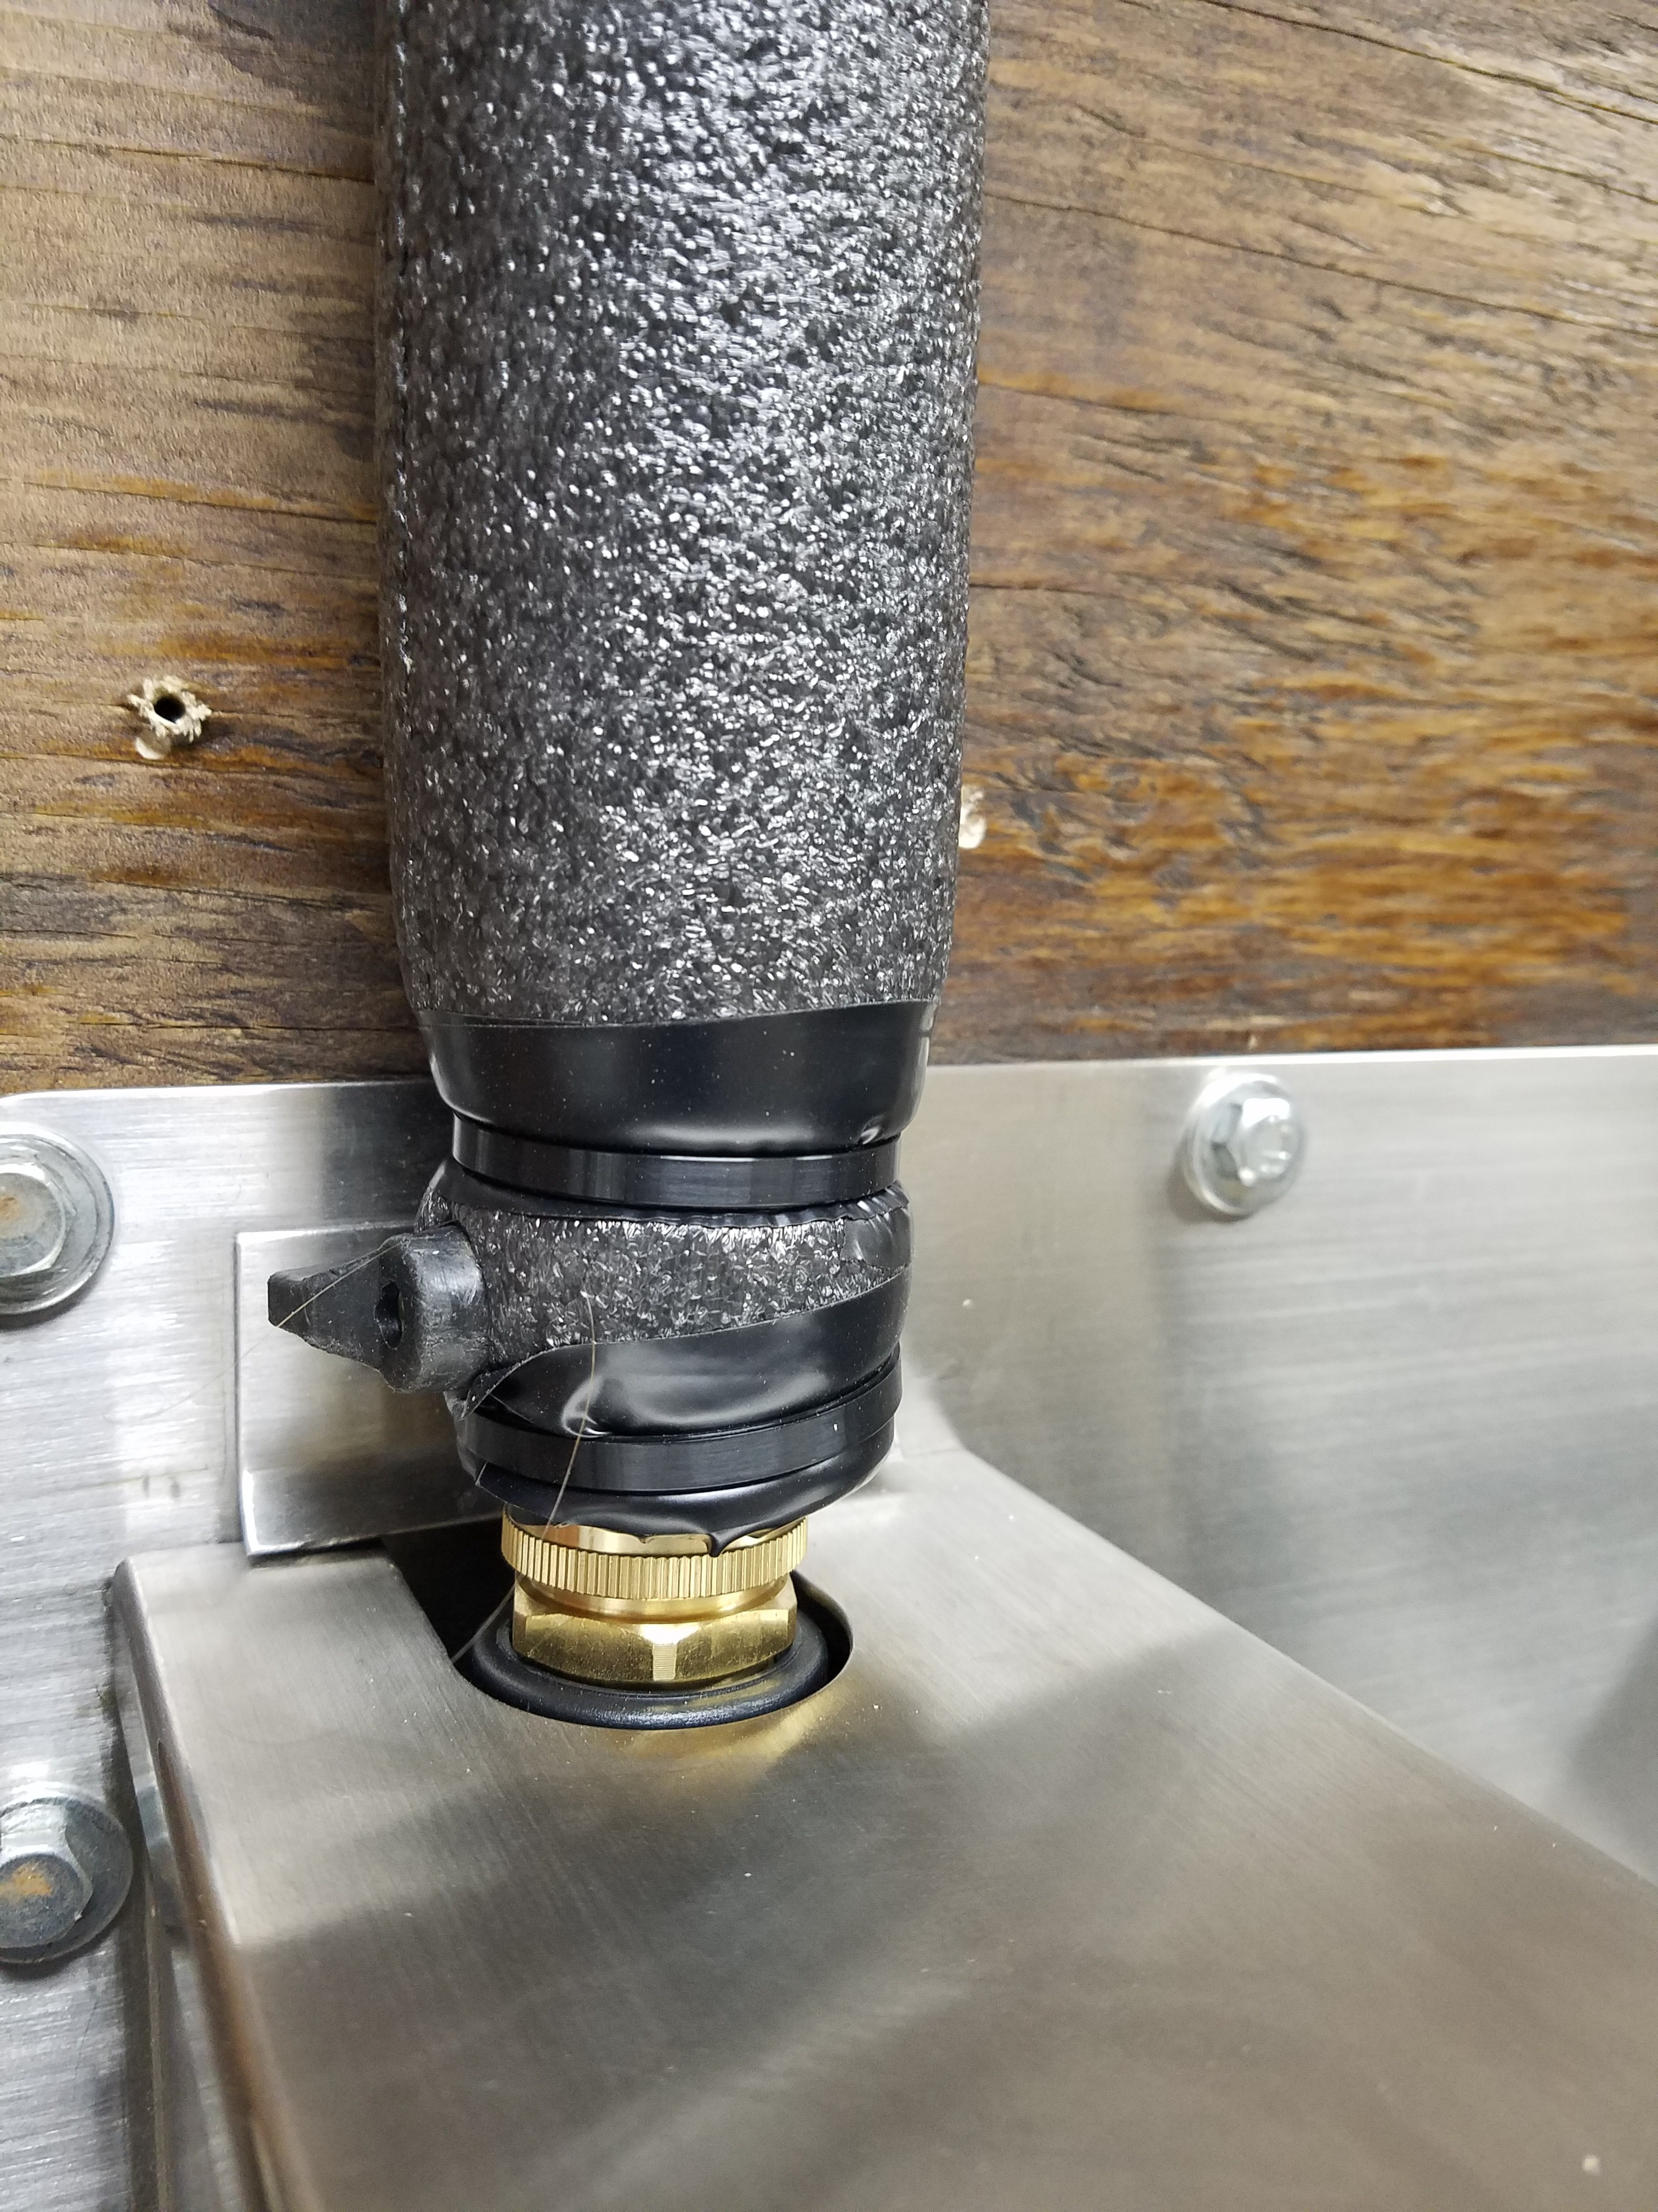Installation Detail # 17900 – Insulating Water Inlet Valve

When taping the insulation around the inlet valve and placing the zip ties it is much easier if you remove the float. Also, leave the bottom portion of the ring on the valve exposed to allow for channel lock tightening.
Wrap Insulation around Inlet Shut-Off valve # 17115 about ½” above float cover. The split on the insulation should face the handle of the valve as illustrated. Tightly wrap with electrical tape both above and below the valve. Install one zip tie above the handle and one zip tie below the handle as shown.

P.O. Box 1026

Texas Superior Animal Waterer, LLC
“DESIGNED FOR THE HORSE”
Fulshear, Texas 77441
tsaw@global-us.net 281-346-8337 www.texassuperioranimalwaterer.com

Silicone Heater Pad with Temperature Control Thermostat
For your convenience, we suggest that you purchase the Texas Superior Animal Waterer with the heater and thermostat mounted and wired and ready for use.
The 6” x 10” silicone heater pad is rated for 110/120 volt power supply and for 150 watts. The pad comes with an industrial adhesive back that is durable and long lasting. The pad is installed on the bottom of the unit and silicone sealed around the edges for additional protection. The design life of the heater unit is approximately 100,000 cycles.
If you already have a unit and want to mount the heater and thermostat and wire it up for operation please contact our office and we will be happy to consult with you and supply you with everything needed, including the temperature control thermostat.
A kit containing everything needed is available that includes the heater pad, temperature control switch and power cord with 3 prong power plug. The process sounds difficult but it is not. The unit comes pre- assembled to simplify the installation. A ground fault receptacle should be utilized as a safety measure.
If a customer prefers, they can send a previously purchased unit to us and we can install the package and return it usually within two three days.
If you prefer to do the installation yourself below are the instructions.

Installation Instructions
- Remove all dirt, grease or other contaminants using a degreaser solvent. Do not use gasoline or Acetone.
- Clean bottom of waterer where pad is to be mounted.
- Etch the surface by using a120 grit wet or dry (black) sand paper. Make circular motions at the selected mounting location.
- Clean the mounting location again with a degreaser and wipe clean with a dry cloth.
- Peel off backing and apply using the 2” diameter drain connection for placement of the pad to waterer bottom. Apply pressure and make sure that there are no air pockets or creases in the pad. Use a roller or spreader to remove any air pockets. Do not touch adhesive surface during or after removal of the release inner backing. Do not reposition the adhesive heater once it comes in contact with the bonding surface or the overall adhesive strength will be greatly reduced.
- Seal the edges of the pad with a high temperature silicone to insure proper protection to the edge of the heater.
- Secure the power cord up and out of the way of any obstructions, making sure that it does not hang down from the bottom of the waterer. Keep cord secure where the horse or other animal is not able to pull or chew the cord.

The voltage is standard 110/120 volt. A ground fault receptacle is mandatory for the heater power cord to be plugged into.
- Do not cut pad for any reason.
Caution!

Silicone heater pads can get very hot and can burn a person or animal. If the heater pad is mounted in the suggested way your animal should be safe but you are the one to decide this for yourself. Texas Superior Animal Waterer, LLC assumes no liability as to the use of these items and the user shall understand that he/she assumes all risks and liabilities.

Temperature Control Thermostat Switch

This type temperature control thermostat switch is widely used in many household appliances and other industrial applications. The switch is designed to come on and activate the heater when the temperature of the water lowers to approximately 34 degrees Fahrenheit. After heating and reaching a temperature of the water to approximately 45 degrees Fahrenheit the temperature thermostat switch will automatically turn off. This process continues and repeats with the temperature change of the water until the ambient temperature stabilizes. This on and off of the thermostat has a direct effect on the temperature of the water in the unit.
Please be aware just because you have the heater installed and the supply line insulated does not guarantee you that the inlet line will not freeze. Therefore, in extremely cold environments you may want to consider the use of a heating cable on the inlet line to insure against freezing.
With this design, a person can plug in the unit and leave all year round without having to worry about the water freezing. However, blizzard like conditions of extreme cold temperatures should be monitored so as a person is comfortable with its workings and performance.
Texas Superior Animal Waterer, LLC heating pad and thermostat are purchased as one integral unit. You will not be able to replace the thermostat without replacing the heater pad. The installation is simple but the wiring must be done by a licensed electrician.
Disclaimer

This designed heater unit has been tested at Texas Superior Animal Waterer, LLC facility only. It has not been tested by any outside testing laboratory and therefore the purchaser/user understands this and assumes all liability and further releases the manufacturer, seller, wholesaler, etc. from any and all liability. The power supply cord must be plugged in to a ground fault receptacle.

TERMS OF LIMITED WARRANTY

Both the silicone heater pad and the temperature control thermostat products sold by Texas Superior Animal Waterer, LLC are warranted for one year from the date of sale to the original consumer against defects in workmanship and materials providing the installation and use of these products are in accordance with Texas Superior Animal Waterer, LLC instructions and applications. Texas Superior Animal Waterer, LLC’s only obligation shall be to replace the product provided it is returned transportation prepaid to Texas Superior Animal Waterer, LLC’s office within one year from date of purchase. Defects or failures to normal wear, incorrect installation, improper voltage, improper usage, improper alterations, or handling, accident, misuse, abuse, neglect, mishandling, misapplication, improper or extradordinary use, inconsistant with its design as represented beyond our control, as to any and all of which Texas Superior Animal Waterer, LLC will be the sole judge, are specifically excluded from this warranty. No other liability of any kind, arising from the use of the product, whether defective of not, is assumed..

No implied warranty of merchantability or fitness for a particular purpose shall apply. The limited warranty contained herin does not extend to incidental or consequental damages resulting from the use of this product, or arising out of a breach of this warranty.

The foregoing limited warranty is exclusive and in lieu of all warranties, whether written or oral, expressed, implied or statory. As a condition of use of these products the purchaser waives, to the fullest extent permitted by law, any warranties beyond those specifically set forth herein.

